**BUSINESS REQUIREMENTS   
DOCUMENT WALK-IN**

# PROJECT DETAILS

|  |  |  |
| --- | --- | --- |
| PROJECT NAME | | |
| Walk-in | | |
| CREATOR | | |
| Joey Dekermenjian & Rami Mahdi | | |
| DOCUMENT NO. | DATE | VERSION NO. |
| 1 | 03/04/2024 | 1.0 |

|  |
| --- |
| 1. EXECUTIVE SUMMARY SNAPSHOT |
| Company Walk-in aims to transform the online shoe shopping experience by offering users a convenient and personalized platform. This project overview provides a detailed description of the purpose, current challenges, and objectives of the project.  The purpose of Company Walk-in is to simplify and expedite the process of purchasing shoes online. By providing a curated selection of shoes and personalized recommendations, the platform seeks to offer users a hassle-free and enjoyable shopping experience. |
|  |

|  |
| --- |
| 2. PROJECT DESCRIPTION |
| The purpose of this project is to create an online platform, Company Walk-in, dedicated to simplifying and expediting the process of purchasing shoes for users. By providing a user-friendly interface and curated selection of shoes, the platform aims to offer convenience and efficiency in the online shoe shopping experience.  Currently, users who wish to buy shoes online must navigate various e-commerce websites or visit physical shoe stores, both of which can be time-consuming and overwhelming due to the abundance of options available. While there are existing online shoe retailers, many lack the personalized touch and curated selection that Company Walk-in seeks to provide.  Challenges:  Overwhelm: Users often feel overwhelmed by the vast array of options available when shopping for shoes online, leading to decision fatigue and dissatisfaction.  Sizing Issues: Finding the right size can be challenging when purchasing shoes online, leading to high return rates and customer frustration.  Lack of Personalization: Existing online shoe retailers may lack the personalization needed to cater to individual preferences and tastes, resulting in a generic shopping experience.  Competition: The online retail landscape is highly competitive, with numerous established players vying for market share. To stand out, Company Walk-in must offer a unique value proposition and superior user experience.  Reasons for Project Undertaking:  Market Demand: There is a growing demand for convenient and personalized online shopping experiences, particularly in the footwear industry.  Opportunity for Differentiation: By offering a curated selection of shoes and personalized recommendations, Company Walk-in can differentiate itself from competitors and attract a niche audience.  Enhanced User Experience: Simplifying the online shoe shopping process will enhance the overall user experience, leading to increased customer satisfaction and loyalty.  Business Growth: Undertaking this project presents an opportunity for revenue growth and market expansion, positioning Company Walk-in as a leader in the online shoe retail space. |

|  |
| --- |
| 3. PROJECT SCOPE |
| OUT-OF-SCOPE ITEMS |
| Manufacturing or Production of Shoes: Company Walk-in will not be involved in the manufacturing or production of shoes. It will solely focus on the retail aspect of the business. |
| Physical Retail Stores: The project does not include the establishment or management of physical retail stores. |
| Third-Party Logistics: While the platform will offer shipping services, the project does not involve managing third-party logistics partners. |
| Legal Compliance: Legal compliance tasks such as obtaining permits or licenses are out of scope for this project. |
| Admin Panel Development: The development of an admin panel for managing platform content, user accounts, and other administrative tasks is out of scope for this project. |

|  |
| --- |
| 4. PROPOSED PROCESS UNKNOWN  NO  YES  UNKNOWN  NO  YES  UNKNOWN  NO  YES  UNKNOWN  NO  NO  NO  NO  NO  NO  NO  NO  NO  NO  NO  NO  NO  NO  NO  NO  NO  NO  NO  NO  NO  NO  NO  NO  NO  NO  NO  NO  NO  NO  NO  NO  NO  NO  NO  NO  NO  NO  NO  NO  NO  NO  NO  NO  NO  NO  NO  NO  NO  NO  NO  NO |
| **Database Tables** |

**Sign Up Activity Diagram**

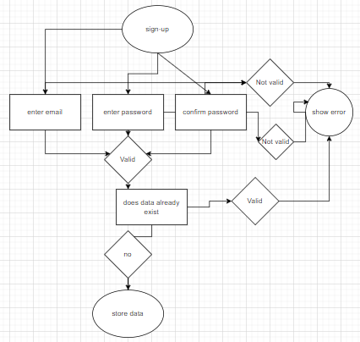

**Add Cart Activity Diagram**

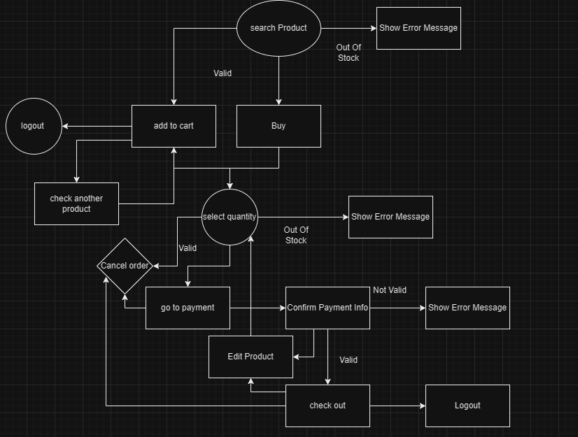

**Admin Activity Diagram**

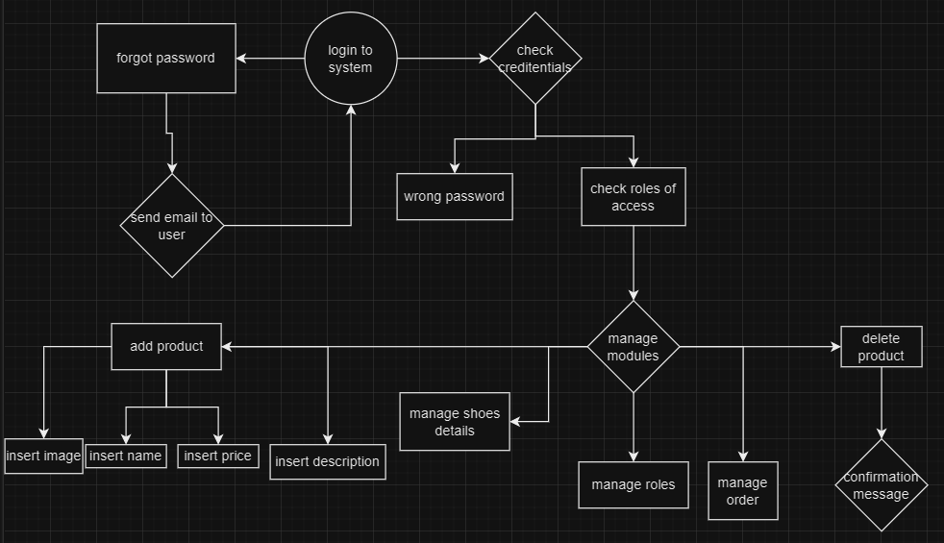

**Change Password Activity Diagram**

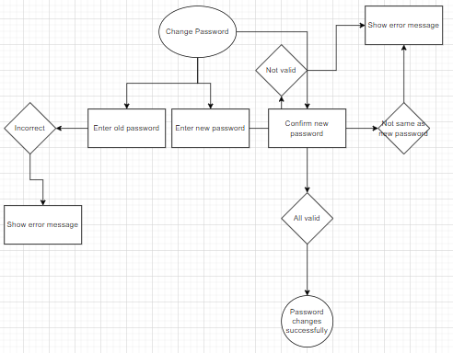

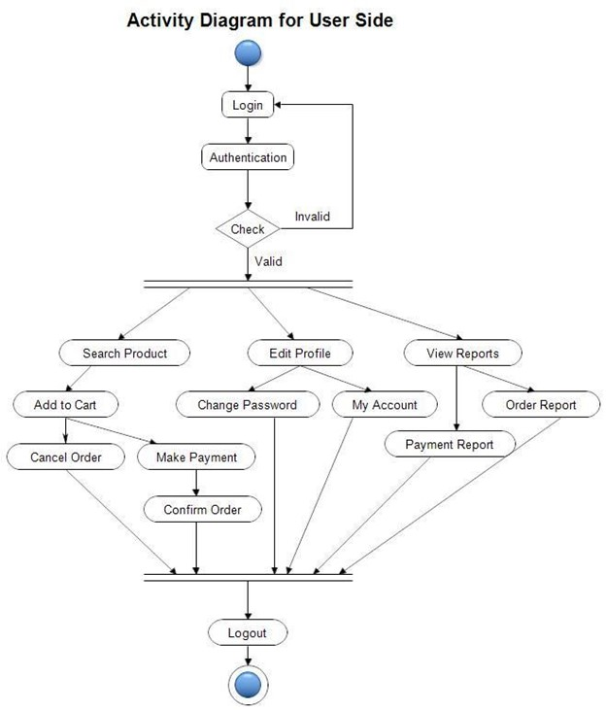

|  |
| --- |
| 5. FUNCTIONAL REQUIREMENTS ( add inno user stories) UNKNOWN  NO  YES  UNKNOWN  NO  YES  UNKNOWN  NO  YES  UNKNOWN  NO  NO  NO  NO  NO  NO  NO  NO  NO  NO  NO  NO  NO  NO  NO  NO  NO  NO  NO  NO  NO  NO  NO  NO  NO  NO  NO  NO  NO  NO  NO  NO  NO  NO  NO  NO  NO  NO  NO  NO  NO  NO  NO  NO  NO  NO  NO  NO  NO  NO  NO  NO |
| [Walk-In] activity diagram: This likely outlines the steps involved in the walk-in process, such as customer arrival, interaction with staff, service provision, etc.  [Walk-In] UI/UX: This involves the user interface and user experience design for the walk-in process, including how customers interact with the system and staff.  [Walk-In] DataBase Tables: This refers to the database tables used to store relevant information about walk-in customers, appointments, services provided, etc.  [Walk-In]_proposal: This could be a document outlining the proposed changes or improvements to the walk-in process.  [Walk-In] Sign-in/Log-in: This likely refers to the process of customers signing in or logging in to the system, possibly to schedule appointments, track service history, etc.  User-friendly Walk-In Process:  The system should provide a clear and intuitive process for walk-in customers, guiding them through each step from arrival to service completion.  The UI/UX design should be optimized for simplicity and ease of use, ensuring a smooth experience for both customers and staff.  Database Management:  The database tables should be designed to efficiently store and retrieve relevant information such as customer details, appointment schedules, service history, etc.  Functional requirements include robust data validation, proper indexing for fast queries, and appropriate data normalization to minimize redundancy and maintain data integrity.  Proposal Implementation:  The proposed changes outlined in the [Walk-In]_proposal document should be implemented effectively to address any identified issues or improve the overall walk-in process.  This may include enhancements to customer service workflows, staff training programs, infrastructure upgrades, etc.  Authentication and Authorization:  The system should provide secure sign-in/log-in functionality for both customers and staff.  Functional requirements include user authentication mechanisms (e.g., username/password, biometric authentication), role-based access control to restrict access to sensitive information, and session management to ensure secure user sessions.  Integration and Scalability:  The system should be designed for easy integration with other relevant systems or modules (e.g., appointment scheduling, payment processing).  It should also be scalable to accommodate potential future growth in customer volume and additional features.  Reporting and Analytics:  Functional requirements should include the ability to generate reports and analyze data related to walk-in traffic, service trends, customer feedback, etc.  This can help in making data-driven decisions to optimize operations and improve customer satisfaction.  Feedback Mechanism:  The system should include a mechanism for collecting feedback from walk-in customers to continuously improve the service quality.  Functional requirements may include surveys, rating systems, and automatic notifications to management for addressing any reported issues. |

|  |  |  |
| --- | --- | --- |
| – PRIORITY | | |
| Use the following priority table. It allows you to apply a ratings system to your requirements, so you have the visibility (into the value, status, and description of each requirement) that is necessary for determining whether a particular requirement is essential to project success. | | |
| **VALUE** | **STATUS** | **DESCRIPTION** |
| 1 | Immediate | The requirement is critical to the project’s success. Without fulfilling this requirement, the project is not possible. |
| 2 | High | The requirement is high priority re the project's success, but the project could still be implemented in a minimum viable product (MVP) scenario. |
| 3 | Moderate | The requirement is important to the project’s success, as it provides value, but the project could still be implemented in an MVP scenario. |
| 4 | Low | The requirement is of low priority, but the project’s success is not dependent upon it. |
| 5 | Prospective | The requirement is out of the project’s scope and is included as a possible component of a prospective release and/or feature. |

|  |  |  |  |
| --- | --- | --- | --- |
| – CATEGORIES (RC1) | | | |
| **ID** | **REQUIREMENT** | **PRIORITY** | **RAISED BY** |
| 798 | [Walk-In] activity diagram | High | Rami Mahdi |
| 790 | [Walk-In] UI/UX | High | Joey Dekermenjian |
| 788 | [Walk-In] DataBase Tables | immediate | Joey Dekermenjian |
| 787 | [Walk-In]_proposal | Moderate | Rami Mahdi |
| 791 | [Walk-In] Sign-up | High | Rami Mahdi |
| 806 | [Walk-In] Login | High | Joey Dekermenjian |

|  |  |
| --- | --- |
| 6. NON-FUNCTIONAL REQUIREMENTS UNKNOWN  NO  YES  UNKNOWN  NO  YES  UNKNOWN  NO  YES  UNKNOWN  NO  NO  NO  NO  NO  NO  NO  NO  NO  NO  NO  NO  NO  NO  NO  NO  NO  NO  NO  NO  NO  NO  NO  NO  NO  NO  NO  NO  NO  NO  NO  NO  NO  NO  NO  NO  NO  NO  NO  NO  NO  NO  NO  NO  NO  NO  NO  NO  NO  NO  NO  NO | |
| **ID** | **REQUIREMENT** |
| 1 | Good performance |
| 2 | Secure payments |
| 3 | Good User interface |
| 4 | User friendly |